**Chapter 1: DATABASE** & **SQL INTRODUCTION**

**1. WHAT IS DATABASE?**

A platform to store any type of data and any amount of Data in a Secured, Faster and Organized format.

**2. WHAT ARE THE BASIC TYPES OF DATABASES? \*\***

|  |  |  |  |
| --- | --- | --- | --- |
| **Type of Databases** | | **Purpose** | **Examples** |
| **OLTP** | **Online Transaction Processing Database** | **LIVE, Real-time** | **LIVE Temperature** |
| **DWH** | **Data Warehouse Database (DWH)** | **Old, Historical Data** | **Past Temp” Data** |
| **OLAP** | **Online Analytical Processing Database** | **Predictions, Forecasts** | **Weather Forecast** |

**3. WHAT ARE THE JOB ROLES & RESPONSIBILITIES?**

**SQL DEVELOPERS** : REPONSIBLE FOR DESIGN OF **OLTP** DATABASES. 100% CODING.

EX: LIVE CRICKET MATCH, STOCK MARKET, ONLINE BANKING….

**DATA ENGINEERS** : REPONSIBLE FOR DESIGN OF **DWH** DATABASES

OLD DATA STORE @ BANK, OLD TEMP DATA @ FORECASTS

**CLOUD COMPUTING, ETL (EXTRACT, TRANSFORM, LOAD)**

MICROSOFT EXAM CODE: DP 203

**DATA ANALYSTS** **:** RESPONSIBLE TO DESIGN **REPORTS** & **DASHBOARDS**

MICROSOFT EXAM CODE: PL 300

**BI DEVELOPER**  : DWH & ETL IN NON CLOUD : **MSBI** [Microsoft BI]

DWH & ETL IN CLOUD : **AZURE DATA ENGINEER**

REPORTS & DASHBOARDS: **POWER BI**

**4. WHAT IS SQL?** A COMMUNICATION PLATFORM TO OPERATE ON ANY DATABASE

MOBILE OS

**5. WHAT IS MSSQL?** A VARIANT OF SQL. ALSO CALLED TSQL [TRANSACT SQL]

USED TO STORE, MANAGE DATABASE IN **MICROSOFT** SQL SERVER.

IPHONE WINDOWS

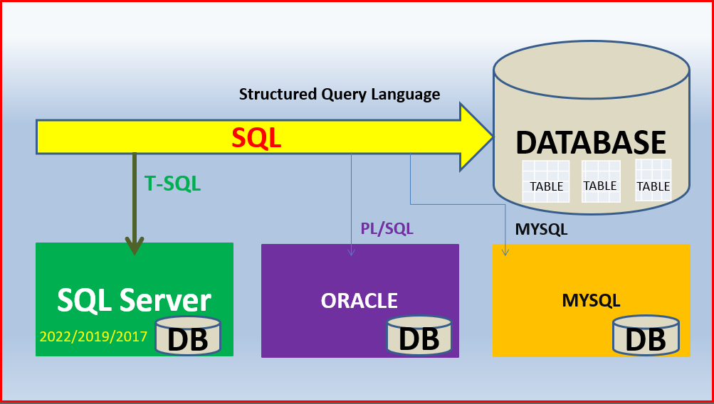

**ITEM 5: WHAT IS DBMS?**

DATABASE MANAGEMENT SYSTEM. IT’S A SOFTWARE.

USED TO DESIGN, MANAGE & ADMINISTER ABOVE DATABASES.

**ITEM 6: WHAT IS SQL SERVER?**

A DBMS FROM MICROSOFT. USER FRIENDLY USER INTERFACE, CHEAPER, FREE SUPPORT

**ITEM 7: VERSIONS?**

SQL SERVER 2022*, SQL SERVER 2019, SQL SERVER 2017, SQL SERVER 2016 ......

**ITEM 8: EDITIONS?**

DEVELOPER*, EVALUATION, EXPRESS EDITIONS : FREE

ENTERPRISE, DATA CENTER, STANDARD EDITIONS : PRICING IS INVOLVED

**ITEM 9: PRE-REQUISTIES?**

None.

We shall start this MSSQL course from the very basics. Step by step.

Make sure you have **Windows** **8** or Higher. 6 GB RAM or Higher.

For Mac : Pls enable Windows inside your Mac or install any Virtual Machine.

+919030040801 +919666440801 + 919951440801

**Course Material Concept wise FAQs Mock Interviews**

**Session Wise Notes Mock Tests Course Completion Certificate**